Name : Pragati Ghorpade
PRN : 2025010550030

Practical 4
1)
Program :
import pandas as pd
# Take inputs from the user to create a list of numbers
numbers = list(map(int, input().split()))
# Create a Pandas series from the list of numbers
series = pd.Series(numbers)
# Grouping by even and odd numbers and calculating the mean
grouped = series.groupby(series % 2 == 0).mean()
# Display the mean of even and odd numbers with labels
grouped.index = ['Even' if is_even else 'Odd' for is_even in grouped.index]
print("Mean of even and odd numbers:")
print(grouped)
Output :
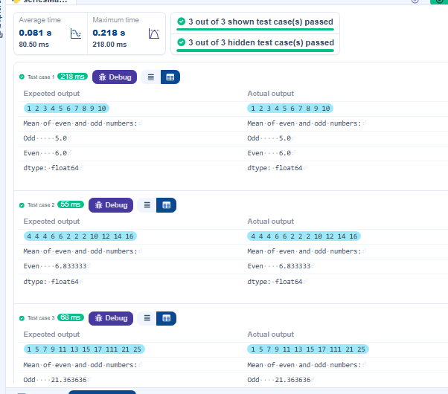

2)
Program :
import pandas as pd

# Provided dictionary of lists
data = {
'Name': ['Alice', 'Bob', 'Charlie'],
'Age': [25, 30, 35],
}

# Convert the dictionary to a DataFrame
df = pd.DataFrame(data)

# Display the original DataFrame
print("Original DataFrame:")
print(df)

# Adding a new row
new_name=input("New name: ")
new_age=int(input("New age: "))
new_row={'Name':new_name,'Age':new_age}
df=df.append(new_row,ignore_index=True)

# Display the DataFrame after adding a new row
print("After adding a row:\n",df)

# Modifying a row
modify_row_index=int(input("Index of row to modify: "))
new_ag_value=int(input("New age: "))
df.at[modify_row_index,'Age']=new_ag_value

# Display the DataFrame after modifying a row
print("After modifying a row:")
print(df)

# Deleting a row
delete_row_index=int(input("Index of row to delete: "))
df=df.drop(delete_row_index).reset_index(drop=True)
# Display the DataFrame after deleting a row
print("After deleting a row:")
print(df)

# Adding a new column
genders=input("Enter genders separated by space: ").split()
df['Gender']=genders

# Display the DataFrame after adding a new column
print("After adding a new column:")
print(df)

# Modifying a column
df['Name']=df['Name'].str.upper()
# Display the DataFrame after modifying a column
print("After modifying a column:")
print(df)

# Deleting a column
df=df.drop(columns=['Age'])
# Display the DataFrame after deleting a column
print("After deleting a column:")
print(df)

Output :
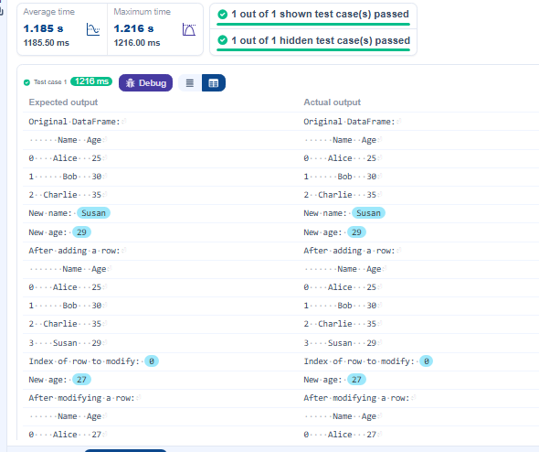

3)
Program :
import pandas as pd

# Read the text file into a DataFrame
file = input()
data = pd.read_csv(file, sep="\s+", header=None, names=["Name", "Age", "Grade"])

# Display the first five rows
print("First five rows:")
print(data.head())

# Calculate the average age of sstudents(limited to 2 decimal places)
average_age = round(data["Age"].mean(),2)
print(f"Average age: {average_age}")

# Filter students with a grade up to 'B'
filtered_students = data[data["Grade"] <= "B"]
print("Students with a grade up to B")
print(filtered_students)
Output :
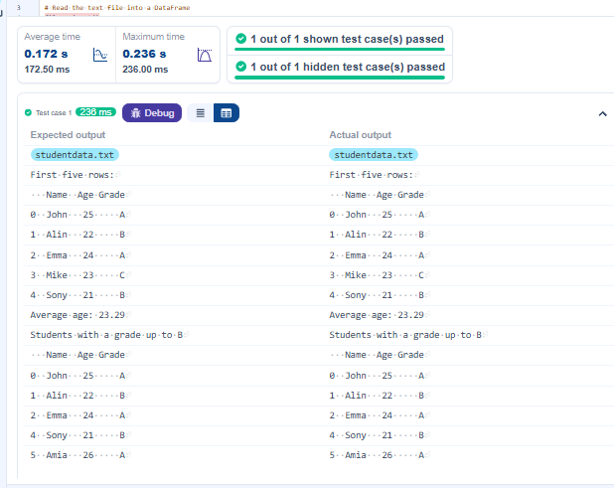

4)
Program :
import pandas as pd

# Prompt the user for the file name
file_name = input()

# Load the data
df = pd.read_csv(file_name)

# Convert the Date column to datetime format
df['Date'] = pd.to_datetime(df['Date'])

# Add a Year-Month column by formatting the Date column
df['YearMonth'] = df['Date'].dt.to_period('M')

# Calculate total sales for each row
df['Total_Sales'] = df['Quantity'] * df['Price']

# Group the data by Year-Month and calculate total sales for each month
monthly_sales = df.groupby('YearMonth')['Total_Sales'].sum()

# Find the month with the highest total sales
best_month = monthly_sales.idxmax()
highest_sales = monthly_sales.max()

print(f"Best month: {best_month}")
print(f"Total sales: ${highest_sales:.2f}")
Output :
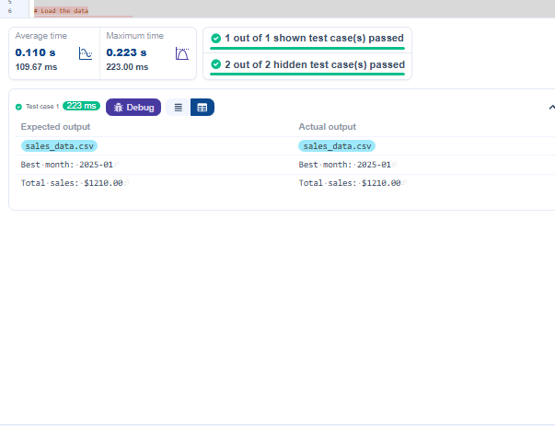
5)
Program :
import pandas as pd

# Prompt the user for the file name
file_name = input()

# Load the data
df = pd.read_csv(file_name)

product_sales = df.groupby('Product')['Quantity'].sum()

# Find the product with the highest total quantity sold
best_product = product_sales.idxmax()
highest_quantity = product_sales.max()

# Display the result
print(f"Best selling product: {best_product}")
print(f"Total quantity sold: {highest_quantity}")
Output :
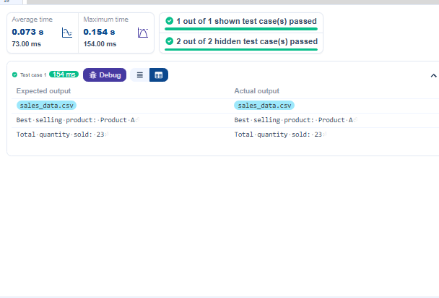

6)
Program :
import pandas as pd

# Prompt the user for the file name
file_name = input()

# Load the data
df = pd.read_csv(file_name)

city_sales = df.groupby('City')['Quantity'].sum()

# Find the city that sold the most products
best_city = city_sales.idxmax()
highest_quantity = city_sales.max()
# write the code..

# Display the result
print(f"City sold the most products: {best_city}")
Output :
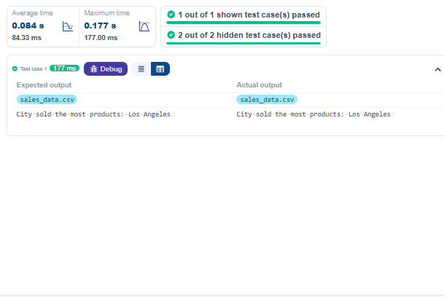

7)
Program :
import pandas as pd
from itertools import combinations
from collections import Counter

# Prompt user to input the file name
file_name = input()

# Read data from the specified CSV file
df = pd.read_csv(file_name)

count_pairs=Counter()
# write the code

for date,group in df.groupby("Date"):
products = group['Product']
for pair in combinations(sorted(products), 2):
count_pairs[pair] +=1

# Output the most frequent product pairs

best_count= max(count_pairs.values())
best_pair= [pair for pair,val in count_pairs.items() if val==best_count ]
for pair in best_pair:
print(f"{pair[0]} and {pair[1]}: {best_count} times")

Output :
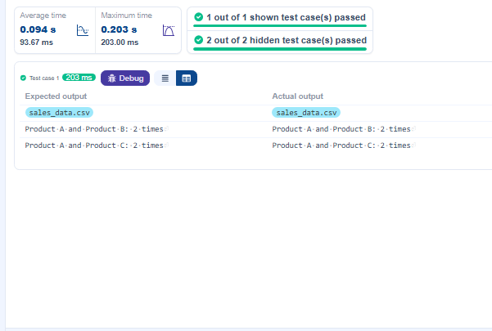
8)
Program :
import pandas as pd
import numpy as np

# Load the Titanic dataset
data = pd.read_csv('Titanic-Dataset.csv')
# 1. Display the first 5 rows of the dataset
print(data.head(5))

# 2. Display the last 5 rows of the dataset
print(data.tail(5))

# 3. Get the shape of the dataset
print(data.shape)

# 4. Get a summary of the dataset (info)
print(data.info())

# 5. Get basic statistics of the dataset
print(data.describe())

# 6. Check for missing values

print(data.isnull().sum())
# 7. Fill missing values in the ‘Age’ column with the median age

# 8. Fill missing values in the ‘Embarked’ column with the mode

# 9. Drop the ‘Cabin’ column due to many missing values

# 10. Create a new column 'FamilySize’ by adding ‘SibSp' and ‘Parch'
Output :
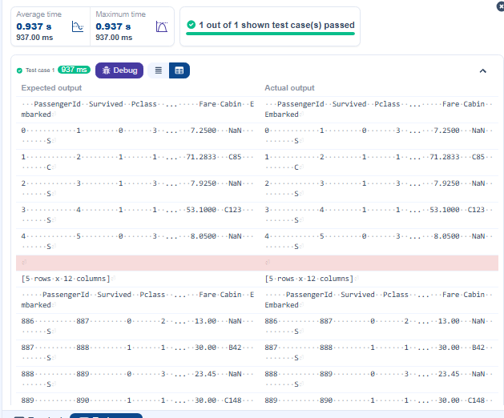
9)
Program :
import pandas as pd
import numpy as np

# Load the Titanic dataset
data = pd.read_csv('Titanic-Dataset.csv')
data['FamilySize'] = data['SibSp'] + data['Parch']
df = pd.DataFrame(data)
# 1. Create a new column ‘IsAlone' (1 if alone, 0 otherwise)
df['FamilySize'] = df['SibSp'] + df['Parch']
df['IsAlone'] = (df['FamilySize'] == 0).astype(int)
# 2. Convert ‘Sex' to numeric (male: 0, female: 1)
df['Sex'] = df['Sex'].map({'male' : 0, 'female' : 1})

# 3. One-hot encode the ‘Embarked' column
df = pd.get_dummies(df, columns=['Embarked'])

# 4. Get the mean age of passengers
mean_age = df['Age'].mean()

# 5. Get the median fare of passengers
median_fare = df['Fare'].median()

# 6. Get the number of passengers by class
passengers_by_class = df['Pclass'].value_counts()

# 7. Get the number of passengers by gender
passengers_by_gender = df['Sex'].value_counts()

# 8. Get the number of passengers by survival status
passengers_by_survival = df['Survived'].value_counts()

# 9. Calculate the survival rate
survival_rate = df['Survived'].mean()

# 10. Calculate the survival rate by gender
survival_rate_by_gender = df.groupby('Sex')['Survived'].mean()
print(mean_age)
print(median_fare)
print(passengers_by_class)
print(passengers_by_gender)
print(passengers_by_survival)
print(survival_rate)
print(survival_rate_by_gender)

Output :
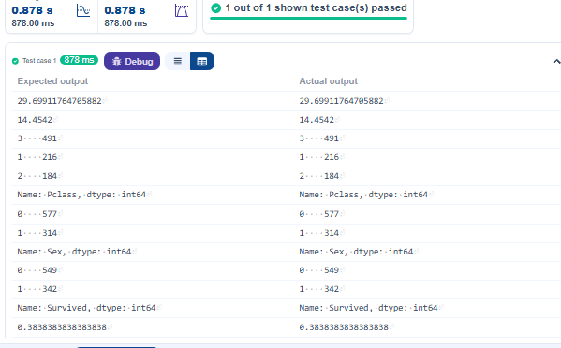
10)
Program :
import pandas as pd
import numpy as np

# Load the Titanic dataset
data = pd.read_csv('Titanic-Dataset.csv')
data['FamilySize'] = data['SibSp'] + data['Parch']
data['IsAlone'] = np.where(data['FamilySize'] > 0, 0, 1)
data = pd.get_dummies(data, columns=['Embarked'], drop_first=True)
df = pd.DataFrame(data)
# 1. Calculate the survival rate by class
grouped = df.groupby('Pclass')['Survived'].mean()
print(grouped)
# 2. Calculate the survival rate by embarked location
print(df.groupby('Embarked_S')['Survived'].mean())

# 3. Calculate the survival rate by family size
print(df.groupby('FamilySize')['Survived'].mean())

# 4. Calculate the survival rate by being alone
print(data.groupby('IsAlone')['Survived'].mean())

# 5. Get the average fare by class
print(data.groupby('Pclass')['Fare'].mean())

# 6. Get the average age by class
print(data.groupby('Pclass')['Age'].mean())

# 7. Get the average age by survival status
print(data.groupby('Survived')['Age'].mean())

# 8. Get the average fare by survival status
print(data.groupby('Survived')['Fare'].mean())

# 9. Get the number of survivors by class
print(data[data['Survived']==1]['Pclass'].value_counts())

# 10. Get the number of non-survivors by class
print(data[data['Survived']==0]['Pclass'].value_counts())

Output :
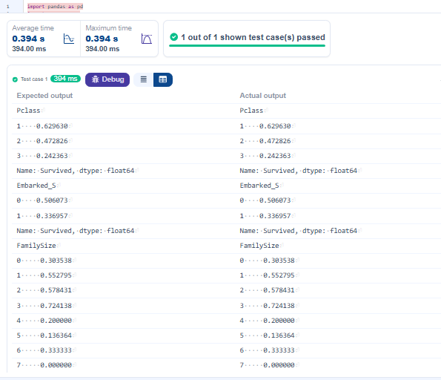
11)
Program :
import pandas as pd
import numpy as np

# Load the Titanic dataset
data = pd.read_csv('Titanic-Dataset.csv')
data = pd.get_dummies(data, columns=['Embarked'], drop_first=True)
df = pd.DataFrame(data)
# 1. Get the number of survivors by gender
print(df[df['Survived']==1]['Sex'].value_counts())
# print((df.groupby('Sex')['Survived']==1).value_counts())
# 2. Get the number of non-survivors by gender
print(data[data['Survived']==0]['Sex'].value_counts())

# 3. Get the number of survivors by embarked location
print(data[data['Survived']==1]['Embarked_S'].value_counts())

# 4. Get the number of non-survivors by embarked location
print(data[data['Survived']==0]['Embarked_S'].value_counts())

# 5. Calculate the percentage of children (Age < 18) who survived
print(data[data['Age']<18]['Survived'].mean())

# 6. Calculate the percentage of adults (Age >= 18) who survived
print(data[data['Age']>17]['Survived'].mean())

# 7. Get the median age of survivors
print(data[data['Survived']==1]['Age'].median())

# 8. Get the median age of non-survivors
print(data[data['Survived']==0]['Age'].median())

# 9. Get the median fare of survivors
print(data[data['Survived']==1]['Fare'].median())

# 10. Get the median fare of non-survivors
print(data[data['Survived']==0]['Fare'].median())

Output :
